

Request for Quotation for the Supply and Delivery of Generator Set

- The Carmona Water District hereinafter referred to as the “Purchaser” now requests for submission of price quotation for the procurement of the aforesaid item described in the Technical Specifications.

- A set of technical specifications are provided in Attachment 1. All items listed under the Purchaser’s Specifications must be complied with on a pass-fail basis. Failure to meet any one of the requirements may result in rejection of the quotation.

- Procurement procedures will be conducted in accordance with the provisions of the Revised Implementing Rules and Regulations (IRR) of Republic Act 9184.

- Quotations must be delivered/faxed/emailed on or before March 30, 2021 at 04:00 PM:

Carmona Water District
Block 8, Lot 8, Joy St., Cityland Subdivision,
Brgy. Mabuhay, Carmona, Cavite
Telefax No. (046) 430-1705
carmonawd@yahoo.com
BAC Secretariat: support@carmonawd.gov.ph

5. Prices must be quoted in Philippine Peso and must include the unit price and total price, inclusive of all taxes to be paid and other incidental cost to the delivery site/s if the contract is awarded.

6. Quotations shall be valid for one hundred twenty (120) calendar days from the deadline of submission of bids.

- The delivery period shall be three to five (3-5) days upon receipt of Purchase Order (PO).

8. The winning bidder/supplier shall submit a notarized Omnibus Sworn Statement, a copy of Mayor’s/Business Permit and Income/Business Tax Return prior to the issuance of Purchase Order as stated in Annex “H” Appendix A of the Revised Implementing Rules and Regulations (IRR) of Republic Act 9184.
*BIR Certificate of Registration shall be submitted in lieu of DTI Registration and Mayor’s Permit.

9. Delivery Site:

Carmona Water District
Block 8, Lot 8, Joy St., Cityland Subdivision,
Brgy. Mabuhay, Carmona, Cavite

10. The applicable rate for late deliveries is one tenth (1/10) of one (1) percent of the cost of the unperformed portion of the contract for every day of delay. The maximum deduction shall be ten percent (10%) of the amount of contract. Once the cumulative amount of liquidated damages reaches ten percent (10%) of the contract amount, the Purchaser shall rescind the contract without prejudice to other courses of action and remedies open to it.

11. The Purchaser reserves the right to accept or reject any proposal, and to annul the procurement process or reject all proposals at any time prior to contract award, without thereby incurring any liability to the affected bidder/bidders.

The Purchaser also reserves the right to waive minor deviations/defects or infirmities therein. A minor deviation/defect or infirmity is one that does not materially affect the overall functionality of the material and the capability of the supplier to perform the contract.

12. The prospective bidder/supplier shall submit the following:

- Quotation Form
- Technical Specifications
- Proof of Philgeps Registration

Sgd.
MS. ROCELISA G. MAULANIN
BAC Chairman

Attachment 1

TECHNICAL SPECIFICATIONS

Brand New Generator Set with Built-in Enclosure and Trailer

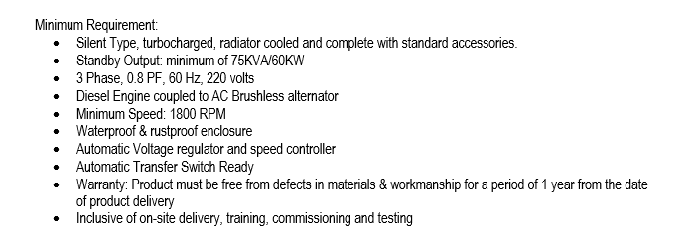

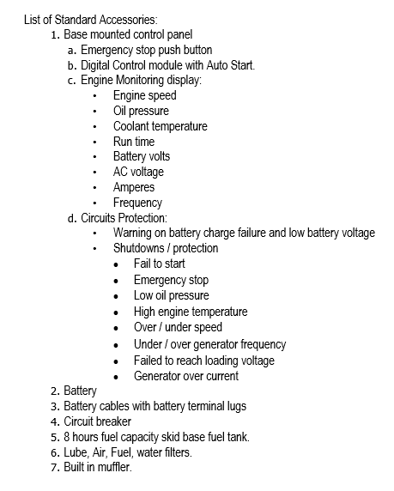

- Terms of Payment: 30 Calendar days upon deliver

- Approved Budget for the Contract: Php700,000.00

- Delivery Site: Carmona Water District
Block 8, Lot 8, Joy St., Cityland Subd.
Brgy. Mabuhay, Carmona, Cavite

- Delivery Period: Three to five(3-5) days upon receipt of Purchase Order

REQUEST FOR QUOTATION FORM
Date:_________________ RFQ. No. 2021-03-0125

Attention: BIDS AND AWARDS COMMITTEE
Block 8, Lot 8, Joy St., Cityland Subdivision, Brgy. Mabuhay,
Carmona, Cavite

1) Having examined the subject Request for Quotation (RFQ) including the Technical Specifications, we, the undersigned offer to supply and deliver the following:

Description | Quantity | Delivery Site | Unit Price | Total Price
Brand New Generator Set with Built-in Enclosure and Trailer | 1 | Carmona Water District

2) We undertake, if our Quotation or bid is accepted, to be available for delivery the above goods within three to five (3-5) days upon receipt of Purchase Order (PO).

3) We agree to abide by this Quotation/bid for a period of one hundred twenty (120) days after the deadline of submission specified in the RFQ.

4) We understand that payment for items delivered will be made in the stated terms of payment to the winning supplier after the inspection and acceptance of goods delivered.
Name of company | : | _______________________________
Postal address | : | _________________________________
TIN No. | : | _________________________________
Telephone/ Fax No./ Email Address | : | _________________________________
Supplier’s representative | : | _________________________________
Signature over printed name | : | _________________________________
Designation | : | _________________________________

Omnibus Sworn Statement

REPUBLIC OF THE PHILIPPINES )
CITY/MUNICIPALITY OF ______ ) S.S.

AFFIDAVIT

I, [Name of Affiant], of legal age, [Civil Status], [Nationality], and residing at [Address of Affiant], after having been duly sworn in accordance with law, do hereby depose and state that:

- Select one, delete the other:

If a sole proprietorship: I am the sole proprietor or authorized representative of [Name of Bidder] with office address at [address of Bidder];

If a partnership, corporation, cooperative, or joint venture: I am the duly authorized and designated representative of [Name of Bidder] with office address at [address of Bidder];

- Select one, delete the other:

If a sole proprietorship: As the owner and sole proprietor, or authorized representative of [Name of Bidder], I have full power and authority to do, execute and perform any and all acts necessary to participate, submit the bid, and to sign and execute the ensuing contract for [Name of the Project] of the [Name of the Procuring Entity], as shown in the attached duly notarized Special Power of Attorney;

If a partnership, corporation, cooperative, or joint venture: I am granted full power and authority to do, execute and perform any and all acts necessary to participate, submit the bid, and to sign and execute the ensuing contract for [Name of the Project] of the [Name of the Procuring Entity], as shown in the attached [state title of attached document showing proof of authorization (e.g., duly notarized Secretary’s Certificate, Board/Partnership Resolution, or Special Power of Attorney, whichever is applicable;)];

- [Name of Bidder] is not “blacklisted” or barred from bidding by the Government of the Philippines or any of its agencies, offices, corporations, or Local Government Units, foreign government/foreign or international financing institution whose blacklisting rules have been recognized by the Government Procurement Policy Board;

- Each of the documents submitted in satisfaction of the bidding requirements is an authentic copy of the original, complete, and all statements and information provided therein are true and correct;

- [Name of Bidder] is authorizing the Head of the Procuring Entity or its duly authorized representative(s) to verify all the documents submitted;

- Select one, delete the rest:

If a sole proprietorship: The owner or sole proprietor is not related to the Head of the Procuring Entity, members of the Bids and Awards Committee (BAC), the Technical Working Group, and the BAC Secretariat, the head of the Project Management Office or the end-user unit, and the project consultants by consanguinity or affinity up to the third civil degree;

If a partnership or cooperative: None of the officers and members of [Name of Bidder] is related to the Head of the Procuring Entity, members of the Bids and Awards Committee (BAC), the Technical Working Group, and the BAC Secretariat, the head of the Project Management Office or the end-user unit, and the project consultants by consanguinity or affinity up to the third civil degree;

If a corporation or joint venture: None of the officers, directors, and controlling stockholders of [Name of Bidder] is related to the Head of the Procuring Entity, members of the Bids and Awards Committee (BAC), the Technical Working Group, and the BAC Secretariat, the head of the Project Management Office or the end-user unit, and the project consultants by consanguinity or affinity up to the third civil degree;

- [Name of Bidder] complies with existing labor laws and standards; and

- [Name of Bidder] is aware of and has undertaken the following responsibilities as a Bidder:

  - Carefully examine all of the Bidding Documents;

  - Acknowledge all conditions, local or otherwise, affecting the implementation of the Contract;

  - Made an estimate of the facilities available and needed for the contract to be bid, if any; and

  - Inquire or secure Supplemental/Bid Bulletin(s) issued for the [Name of the Project].

- [Name of Bidder] did not give or pay directly or indirectly, any commission, amount, fee, or any form of consideration, pecuniary or otherwise, to any person or official, personnel or representative of the government in relation to any procurement project or activity.

IN WITNESS WHEREOF, I have hereunto set my hand this __ day of ___, 20__ at ____________, Philippines.

_____________________________________
Bidder’s Representative/Authorized Signatory

